
Welcome to Salomon Solar: Pioneering Affordable Solar Solutions in Sint Maarten
Thank you for your interest in Salomon Solar, a fresh and passionate consultancy dedicated to sustainable, cost-effective solar energy solutions. We're more than a business; we're a community-focused team driven to make solar energy both accessible and affordable.
Our Approach: We keep operational costs low, choosing only the highest quality products. Our unique model means we sell inverters and other components at cost, only adding a minimal markup on solar panels and batteries to cover testing and assembly. Additionally, we offer used solar panels, providing significant savings without compromising on quality.
Our Services:
- Education and Advisory: Guiding you through understanding and meeting your energy needs with solar technology.
- Custom Battery Solutions: Designing and building tailor-made battery systems for reliable power.
- Sourcing Components: Acquiring solar panels and components at the lowest costs through established industry contacts.
Our Commitment: We focus on consultancy and design while partnering with trusted local installers and licensed electricians to ensure your solar setup is safe and effective.
Why Choose Us? At Salomon Solar, we're committed to our community. We ensure that everyone in Sint Maarten can access high-quality, affordable solar power.
Join Us: Let's transform our energy future together. Contact us today to see how you can benefit from solar energy efficiently and affordably.

Salomon Solar Intake Survey
Introduction: Welcome to Salomon Solar! Before we recommend a solar system, we suggest starting by reducing your overall energy consumption. This step not only lowers your energy bills but also decreases the size and cost of the solar system you'll need.
Survey Questions:

- General Information:
  - Property Type (Residential/Commercial):
- Energy Usage Overview:
  - What is your average monthly electricity consumption in kWh?
  - 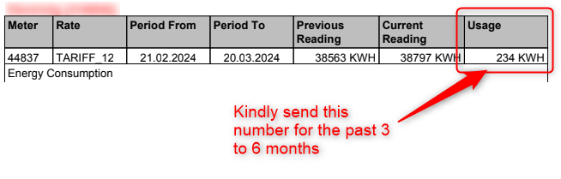
- Energy Reduction:
  - Have you undertaken any recent measures to reduce your energy consumption? (Yes/No)
- System Preferences:
  - Are you interested in reducing your energy bills, going off-grid, or both?
  - During power outages, what percentage of your normal electricity needs do you want to meet with your solar system? (E.g., 60%, 100%)
- Critical Loads:
  - What appliances and systems must remain operational during an outage? (E.g., AC, refrigerator, lighting)
  - Total wattage of these critical appliances:
- Site Assessment:
  - Do you have available space for installing solar panels? (Yes/No)
  - Please provide photos or a brief description of the intended installation area.
- Budget:
  - What is your budget range for your solar system investment?
    - 1200 – 2000
    - 2000 – 4000
    - 4000 – 6000
    - 6000+
Conclusion: Thank you for completing our intake survey. Based on your responses, we will design a solar system tailored to your specific needs and preferences. A representative will contact you shortly to discuss the next steps.
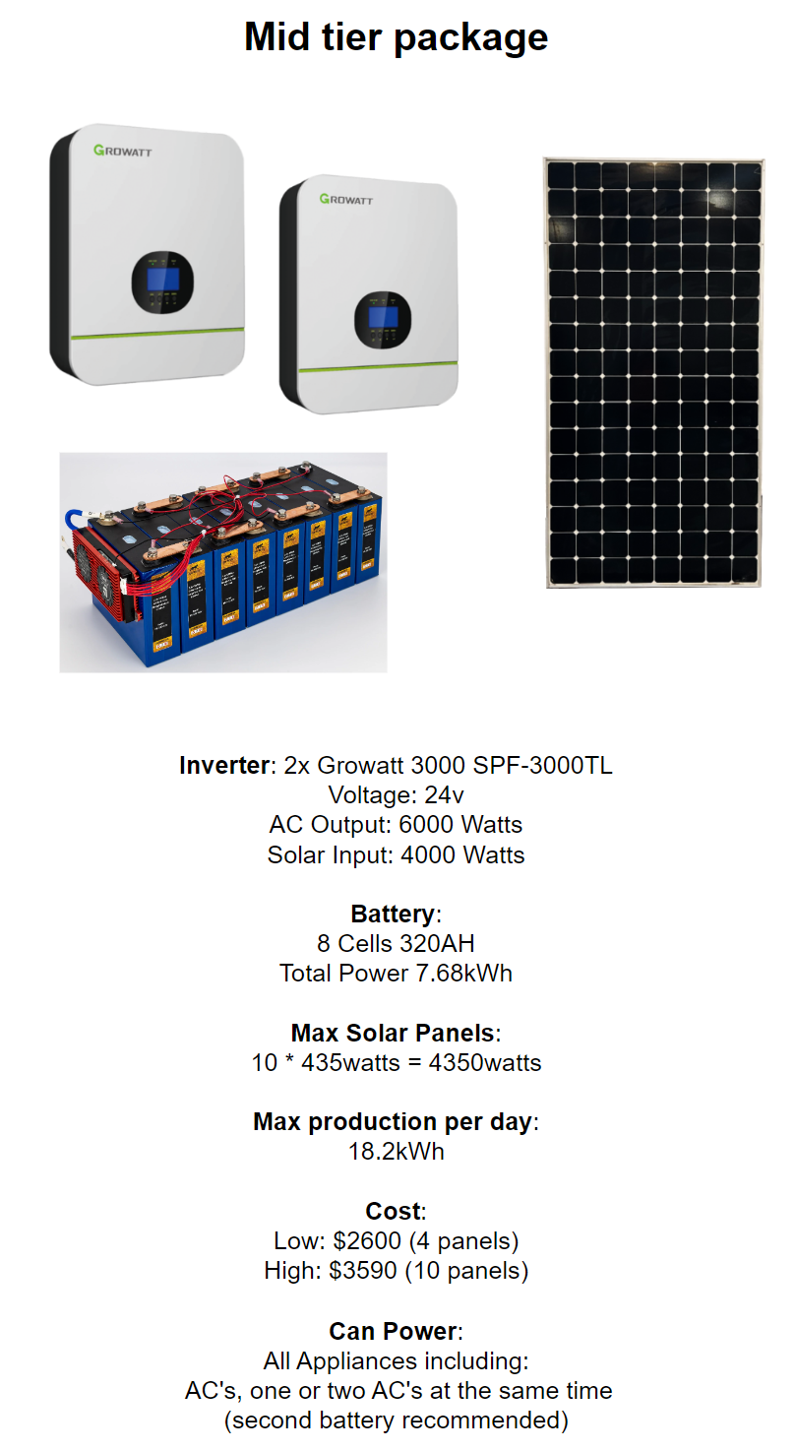
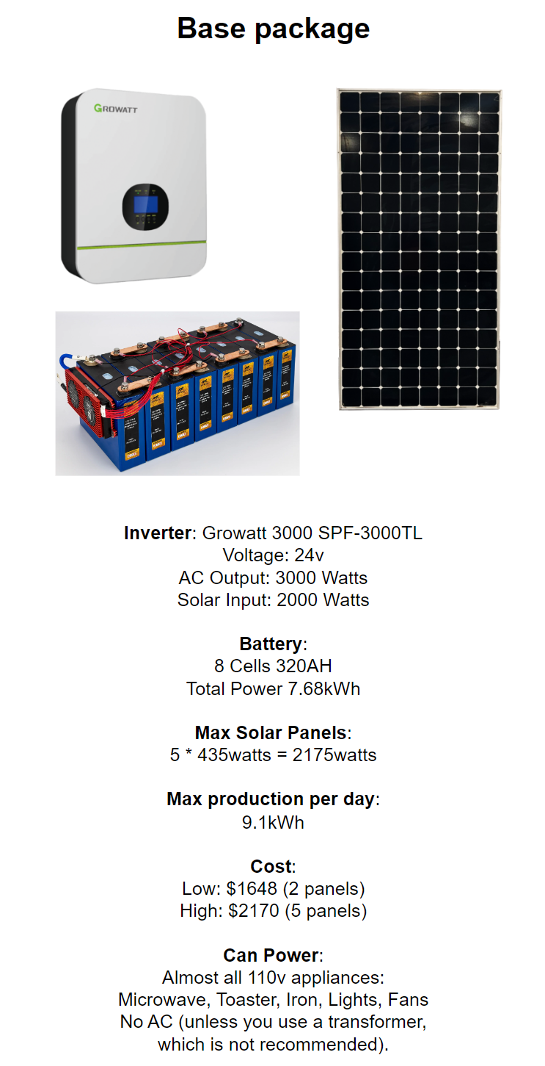
Package Overview
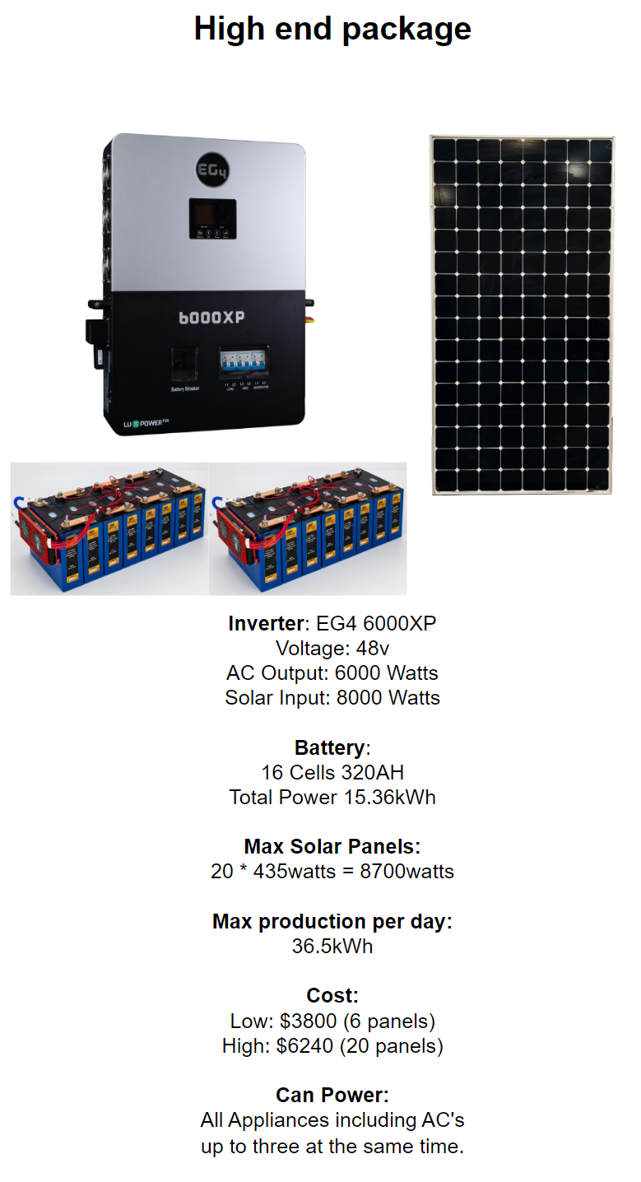
Package Overview Continued

